# Configure a Test Application Load Balancer

Your company is interested in migrating their existing domains to the AWS infrastructure, and in utilizing the Route 53 service. For a proof of concept, there will have to first be a resource to point to and use for a record set.

Log in to the AWS Management Console and complete the following steps:

1. Click on the **Open AWS console** link to the right of this text, then use the credentials provided to log in to AWS.
2. Use the search bar at the top of the page to navigate to the **EC2** service.
3. On the left, under **Load Balancing**, select **Load Balancers**.
4. Click **Create Load Balancer**.
5. Click on **Create** under **Application Load Balancer**.
6. At the **Create Application Load Balancer** page, configure the load balancer with the following settings:
   * Name : TESTALB
   * Scheme: **Internal**
   * Network mapping > Mappings: select all four boxes, **us-west-2a**, **us-west-2b**, **us-west-2c**, and **us-west-2d**.

You can ignore any subnet error messages for this lab.

1. In the **Listeners and routing** section, click **Create target group.**
2. In the new browser tab, set the **Target group name** to TESTTG. Click **Next** and then **Create target group.**
3. Close the **Target groups** browser tab, and back at the Create Application Load Balancer page, still under the **Listeners and routing** section, click the section's refresh button, then from the **Default action** drop-down, select **TESTTG**.
4. Finally, click **Create load balancer**, then click **View load balancer**.

You'll see the new **TESTALB** application load balancer in the table.

# Create an Internal Hosted Zone

Now there has to be an internal hosted zone created to be able to support other record types and record routing policies.

1. In the top search bar type in and click on **Route 53**.

You can ignore any Route 53 error messages; they do not matter for this lab.

1. In the left-hand menu, click **Hosted zones**.
2. Click **Create hosted zone**.
3. Enter a **Domain name** of test.com.
4. Choose **Private hosted zone**.
5. In the **VPCs to associate with the hosted zone** section, from the **Region** drop-down select **US West (Oregon)**, then click the **VPC ID** search field and choose the only VPC listed.
6. Click **Create hosted zone.**

Once your hosted zone has been created you should see two listings in the **Records** section.

# Create a Primary and Secondary Record Set

You are now tasked with testing out the different routing policies for record sets in Route 53, specifically a failover routing procedure.

1. At Route 53's **Hosted zones** page, click **Create record**.
2. Click **Switch to wizard**.
3. Under the **Choose Routing Policy** section, select **Failover** and click **Next**.
4. At the **Configure records** page, enter the **Record name** aspractice.
5. In the **Failover records to add to test.com** section, click **Define failover record**.
6. In the Define failover record pop-up, enter the following:
   * In the drop-down for **Value/Route traffic to**, choose **Alias to Application and Classic Load Balancer**.

Note: As of about mid-August 2022, Classic Load Balancers are being retired, so this option's name may change, perhaps to just Alias to Application Load Balancer.

* + Select **US West (Oregon)** as the region
  + Then from the next drop-down select the **TESTALB** load balancer. (It will be a full URL with TESTALB in it. See the screenshot below for an example)
  + For **Failover record type**, select **Primary**.
  + Make sure the Evaluate target health toggle is set to Yes.
  + For **Record ID**, enter practice-primary.

﻿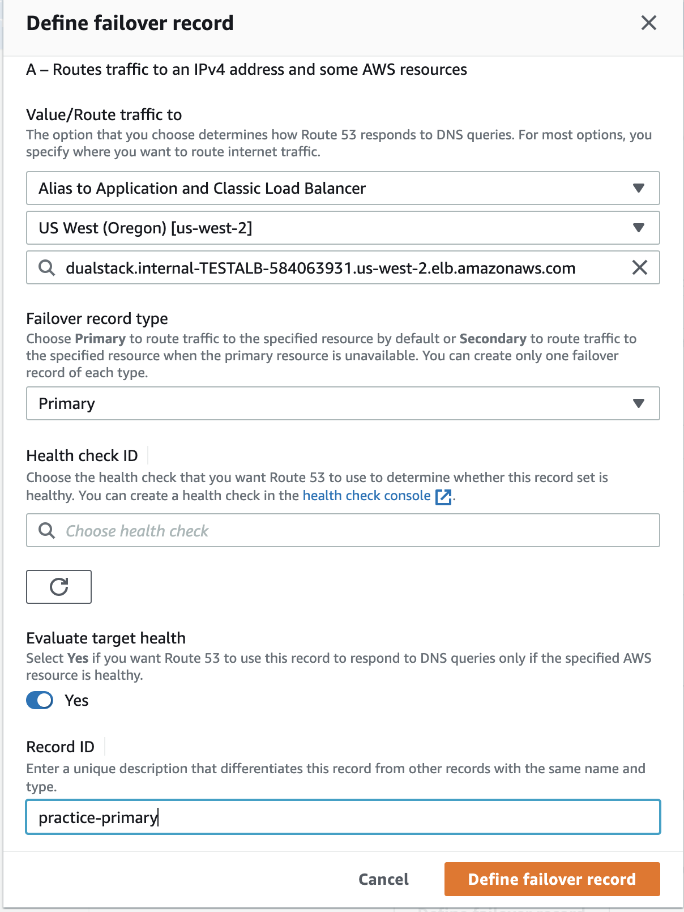Click **Define failover record**.

1. Click **Define failover record** to create one more failover record.
2. Repeat task **6**, but set the **Failover record type** to **Secondary** and the **Record ID** to practice-secondary.
3. Click **Create records**.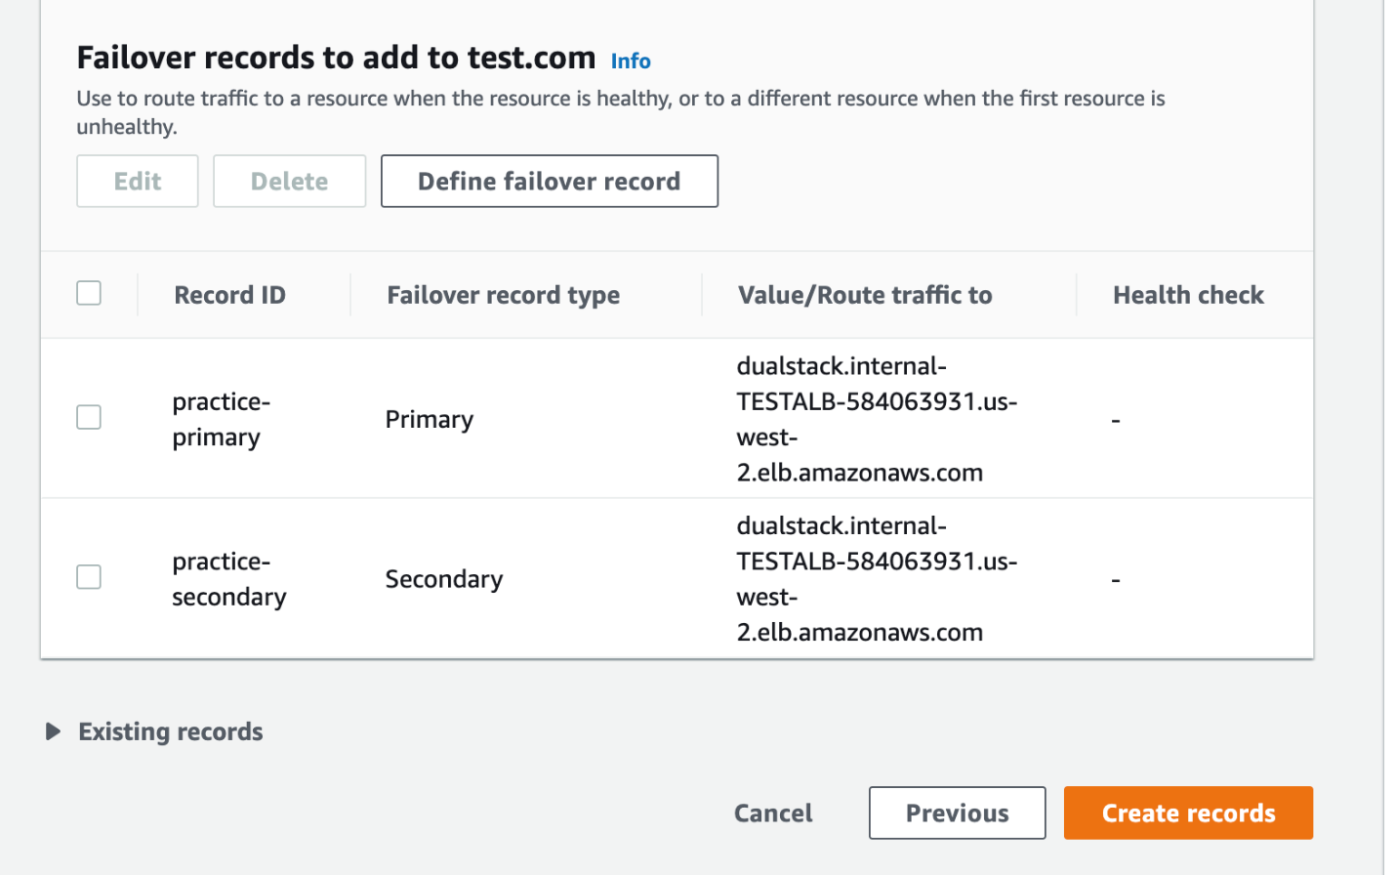﻿

You will see two record sets named **practice.test.com** listed in the **Records** section, one being **Primary** and the other **Secondary**.

# Create a Health Check

Your employer now wants to utilize more of the services available in Route 53, specifically health checks. This will facilitate the failover routing policies in the record sets.

1. From the left-hand menu click **Health checks**.

You may first, in the upper-left, need to expand the menu by clicking ☰**.**

1. Click **Create health check**.
2. Configure the health check with the following values:
   * Name: TESTHC
   * Specify endpoint by: **Domain Name**
   * Domain name: test.com
3. Click **Next**.
4. Click **Create health check**.
5. From the left-hand menu, click on **Hosted Zones**.
6. Click on **test.com**.
7. Select the checkbox for the first **practice.test.com** record that is the **Primary**.
8. In the **Record Details** section, click **Edit record.**
9. In the **Health check** section, choose **TESTHC** from the drop-down.
10. Click **Save**.

You have now associated a health check for the failover records. You can add the health check to the secondary record for practice.test.com if you'd like to practice.

You now have a framework in place for resources that test application load balancer. For full production-level infrastructure, you could create a second ALB, associate it with the secondary record, and set and create redundant resources to be in a true “fail over” environment.